Predicting Student Loan Delinquency Post-CARES Act Using SHED Data
Heather F Weston
Western Governors University

Table of Contents
A. Project Highlights 3
B. Project Execution 4
C. Data Collection Process 5
C.1 Advantages and Limitations of Data Set 6
D. Data Extraction and Preparation 7
E. Data Analysis Process 10
E.1 Data Analysis Methods 10
E.2 Advantages and Limitations of Tools and Techniques 11
E.3 Application of Analytical Methods 12
F Data Analysis Results 13
F.1 Statistical Significance 13
F.2 Practical Significance 14
F.3 Overall Success 15
G. Conclusion 16
G.1 Summary of Conclusions 16
G.2 Effective Storytelling 18
G.3 Recommended Courses of Action 20
H Panopto Presentation 22
References 23
Appendix A 24
Visualizations Supporting Analytical Findings 24
Appendix B 32
Summary of Coefficient Comparisons Across Models 32
Appendix C 36
Supporting Python Code 36

A. Project Highlights
Research Question / Organizational Need
This capstone project addresses the growing concern around student loan delinquency, particularly in the wake of the CARES Act payment pause and its subsequent expiration. The central research question guiding the project was: What borrower characteristics and financial indicators are most predictive of student loan delinquency, and how do these patterns differ before and after the COVID-19 payment pause? This question aims to support policymakers and loan servicers in identifying at-risk borrowers and tailoring outreach or support programs more effectively.
Scope of the Project
The project focused on analyzing microdata from the Federal Reserve’s Survey of Household Economics and Decisionmaking (SHED) (Survey of Household Economics and Decisionmaking, 2025), covering the years 2015 to 2024. The analysis was limited to respondents with student loan debt and included comparisons of delinquency trends before the CARES Act (2015-2019), during the pause (2020-2022), and after resumption (2023-2024). The scope included descriptive, diagnostic, and predictive analyses to better understand the relationship between borrower demographics, credit indicators, and delinquency outcomes.
Overview of the Solution
To address the research question, the project employed a combination of data cleaning, exploratory data analysis, and logistic regression modeling. The data was processed and analyzed using Python in a Jupyter Notebook environment. Categorical variables were one-hot encoded, and logistic regression was used to identify statistically significant predictors of delinquency. The model was trained and evaluated across three different time frames, pre-CARES, post-resumption, and a combined model, to assess how borrower risk factors evolved. Visualization tools such as matplotlib and seaborn were used to communicate key findings, and the results were interpreted with practical implications in mind for identifying systemic risk and targeting support.

B. Project Execution
Project Plan (Task 2 - B1)
The overall project plan remained consistent with what was outlined in Task 2. The core objective, to analyze student loan delinquency trends using SHED data across multiple years and to build predictive models for identifying at-risk borrowers, was executed as originally proposed. No significant variances occurred in the high-level direction or purpose of the project, as the dataset and tools selected proved to be appropriate and sufficient for answering the research question.
Project Planning Methodology (Task 2 - B3)
The methodology largely followed the structure developed in Task 2. Data cleaning, exploratory analysis, and predictive modeling (via logistic regression) were all executed as planned. One small deviation occurred in the modeling phase: while the initial plan called for separate models pre- and post-CARES Act, an additional combined model was developed to assess trends across the full time span (2015-2024). This refinement was introduced based on insights discovered during exploratory analysis and provided a more holistic understanding of borrower risk factors. However, this addition did not require changes to the overall methodology and aligned with the project's goals.
Project Timeline and Milestones (Task 2 - B4)
The project timeline was followed closely, and all major milestones were met within the expected timeframes. The only minor adjustment involved extending time for data preprocessing and alignment across survey years, due to inconsistencies in variable naming and response formats within the SHED datasets. This task required additional effort to standardize the data and ensure a clean structure for modeling. Despite this, the delay was minor and did not affect the delivery of the final analysis. The ability to reuse and adapt existing code streamlined the remainder of the process, keeping the project on track overall.

C. Data Collection Process

Data Selection and Collection Variances (Task 2 - D3)
The data selection process generally aligned with the original plan, which focused on using the Survey of Household Economics and Decisionmaking (SHED) (Survey of Household Economics and Decisionmaking, 2025) microdata from 2015 to 2024. The primary dataset centered on respondents with student loans, with a focus on loan status and delinquency. During the project, the scope was slightly expanded to include variables related to credit access and financial well-being, providing a more comprehensive basis for analysis and modeling.

An additional unplanned adjustment was made when exploring Federal Student Aid loan portfolio data (Federal Student Loan Portfolio, 2025). While these datasets provided robust aggregate figures on delinquency rates, they lacked accompanying demographic information. This limited their usefulness for modeling or subgroup analysis. To address this, comparisons between delinquency rates and borrower characteristics were drawn using SHED data, which offers rich individual-level demographic and financial responses. The SHED data was therefore essential for building predictive models and understanding borrower risk profiles.

Obstacles Encountered During Data Collection (Task 2 - D4)
Although the core SHED datasets were publicly accessible, preprocessing presented several challenges. Notably, there were inconsistencies in variable names, formats, and survey question wording across different years. These inconsistencies required substantial effort to reconcile. A custom preprocessing function was developed to standardize variable names and harmonize categorical responses across survey years, which enabled consistent year-to-year comparisons.

Additionally, because some relevant statistics (e.g., aggregate delinquency trends by demographics) were only published in the SHED annual summary reports—and not available in downloadable microdata—some information had to be manually extracted or scraped from PDF tables or web content to support contextual comparisons.

Unplanned Data Governance Issues (Task 2 - D5)
No unplanned data governance issues arose during the project. All data sources were publicly available, de-identified, and published by official government agencies. There were no concerns related to privacy, licensing, or ethical compliance. Proper citation and attribution practices were followed, and all data use remained within the bounds of responsible data governance.

C.1 Advantages and Limitations of Data Set
Advantages
One major advantage of the SHED dataset is its depth of individual-level demographic and financial information. It provides detailed data on student loan status, repayment behavior, income, employment, credit access, and financial well-being. This granularity allowed for a multifaceted analysis of delinquency trends, especially when exploring how factors such as income level, race/ethnicity, or employment status influence loan repayment outcomes.
For example, because SHED includes race and income categories alongside student loan delinquency responses, the analysis was able to identify demographic subgroups with disproportionately high delinquency rates—an insight that would not be possible using aggregate portfolio data alone.
Limitations
A key limitation of the SHED dataset is its relatively small sample size and cross-sectional structure. While SHED is nationally representative, it only surveys a few thousand individuals each year, which limits the ability to perform highly granular subgroup analysis or track the same borrowers over time. In addition, certain years had lower response counts for specific questions related to student loans, reducing the sample available for modeling.
Another limitation is that while the Federal Student Aid loan portfolio data offers more comprehensive national statistics, it does not include borrower-level demographics. This forced reliance on SHED for demographic insights, and while valuable, SHED's smaller sample and self-reported responses may introduce sampling or reporting bias compared to administrative datasets.

D. Data Extraction and Preparation
Data Extraction
The data extraction process was primarily focused on accessing the publicly available SHED (Survey of Household Economics and Decisionmaking) microdata from the Federal Reserve’s official website. Annual datasets from 2015 to 2024 were downloaded in CSV format and read into Python using the pandas library. Since each year’s SHED data is provided in a separate file with varying variable names and response codings, the extraction process required consolidating and importing multiple files individually.
Python and Jupyter Notebooks served as the primary tools for extraction and initial inspection. The os, glob, and pandas libraries were used to automate the file reading and aggregation process, allowing for flexible iteration across yearly data files.
Why This Process Was Appropriate
The manual extraction and year-by-year inspection were necessary due to the inconsistency in column names and survey questions across SHED years. Unlike structured APIs or databases, SHED data lacks schema uniformity, so a manual and script-driven approach was the most effective way to ensure integrity during extraction. This hands-on method enabled the identification of key variable inconsistencies early in the process, which informed the cleaning strategy.
Data Preparation
Preparation involved extensive data cleaning and restructuring to align SHED datasets across multiple years. Key steps included:
- Standardizing column names (e.g., renaming variables like D3, D3_1, or SLDELINQ into consistent terms such as student_loan_delinquency)
- Harmonizing categorical response formats (e.g., ensuring that race/ethnicity or income brackets were consistently coded)
- Filtering for relevant subpopulations (e.g., borrowers with outstanding student loans)
- Creating derived variables (e.g., binary flags for delinquency, consolidated demographic groupings)
- Handling missing values and invalid responses
These steps were implemented in Python using pandas for data manipulation, numpy for numeric transformations, and scikit-learn for encoding categorical variables (via OneHotEncoder) in preparation for predictive modeling.
Why These Techniques Were Appropriate
Given the complexity and variation of the raw data, the use of Python and pandas was well-suited for flexible, repeatable preprocessing. Custom functions were written to clean and align variables across years, enabling streamlined preparation of a master dataset. This ensured that logistic regression models could be trained on a consistent feature set, avoiding data leakage and ensuring comparability across time periods.
Overall, the extraction and preparation process was designed specifically to meet the demands of a longitudinal, multi-year, multi-file dataset, making it an appropriate and necessary approach for the analysis.

E. Data Analysis Process

E.1 Data Analysis Methods

To analyze the relationship between borrower characteristics and student loan delinquency, the project employed a combination of descriptive statistics, exploratory data analysis (EDA), and logistic regression modeling.

Descriptive Statistics and EDA: These methods were used to summarize key borrower characteristics (e.g., age, race, income, education level) and compare distributions between delinquent and non-delinquent borrowers. Tools such as pandas, matplotlib, and seaborn were used to generate frequency tables and visualizations (e.g., bar plots and heatmaps) that identified trends across years and demographics. This was appropriate for identifying patterns and informing variable selection for modeling.

Logistic Regression: The primary analytical method used to support the project’s hypothesis was logistic regression, a classification technique suited for binary outcomes such as loan delinquency (yes/no). Logistic regression was applied across three contexts: pre-CARES Act (2015-2019), post-resumption (2023-2024), and a combined model across all years (2015-2024). This allowed for comparative analysis of how risk factors changed over time. The method was appropriate because it provides interpretable coefficients and probabilities, helping identify which borrower features significantly contribute to delinquency risk.

E.2 Advantages and Limitations of Tools and Techniques

Python / Jupyter Notebooks

Advantage: Python offers a rich ecosystem of libraries (e.g., pandas, numpy, scikit-learn, matplotlib) for data analysis, modeling, and visualization. Jupyter Notebooks allow for code, output, and commentary to coexist, making the workflow reproducible and easy to document.

Limitation: Jupyter Notebooks can become unwieldy with large data pipelines and multiple iterations. Without careful organization, outputs and intermediate steps may lead to confusion or misinterpretation.

Pandas / NumPy (for EDA and preprocessing)

Advantage: Extremely flexible for cleaning and transforming large, messy datasets like SHED. Allowed for efficient filtering, grouping, and reshaping of borrower-level data.

Limitation: Pandas is memory-bound, and operations across multiple large CSVs (SHED 2015-2024) required careful handling to avoid performance issues.

Matplotlib / Seaborn (for visualization)

Advantage: Enabled the creation of clear, customizable plots to visually highlight demographic differences in delinquency rates.

Limitation: Complex plots (e.g., multi-year facet grids or conditional distributions) can require extensive tuning and offer limited interactivity.

Scikit-learn (for logistic regression and encoding)

Advantage: Provided robust and standardized tools for preprocessing (e.g., OneHotEncoder) and model development (LogisticRegression), making the process repeatable and modular.

Limitation: Scikit-learn’s logistic regression assumes linearity in the log-odds and does not natively handle imbalanced classes or interaction effects without explicit modeling.

E.3 Application of Analytical Methods

Step-by-Step Methodology:

Data Preprocessing

Imported SHED microdata (2015-2024), filtered for student loan borrowers.

Standardized column names and responses across years to enable merging.

Applied OneHotEncoder to categorical variables (e.g., race, income, education).

Created a binary target variable (is_delinquent) based on survey responses.

EDA and Variable Selection

Visualized distributions of target and predictor variables.

Compared borrower characteristics across delinquent vs. non-delinquent groups.

Selected features based on theoretical relevance and data completeness.

Model Development

Split data into training and testing subsets (when applicable).

Fit logistic regression models using scikit-learn, one for each period (pre-CARES, post-resumption, and combined).

Examined model coefficients, p-values, and accuracy to interpret risk factors.

Assumptions and Verification

Binary Outcome: Confirmed that the dependent variable was binary (delinquent vs. not).

Linearity of Log-Odds: While logistic regression assumes linearity in the logit, visual inspection of relationships and variable encoding helped reduce nonlinearity.

Multicollinearity: Correlation matrices were reviewed to minimize redundant predictors.

Sample Size: Ensured that the number of observations per predictor variable was sufficient, especially in the combined model.

Each step was repeated across the three models, enabling direct comparison of feature importance over time and strengthening the overall reliability of the analysis.

F Data Analysis Results

F.1 Statistical Significance

Model Type:
Supervised classification model

Algorithm Used:
Logistic regression using the scikit-learn library

Process:
The logistic regression model was trained on SHED data to predict whether a borrower was delinquent on student loan payments. Models were built across three segments: pre-CARES (2015-2019), post-resumption (2023-2024), and combined (2015-2024). The predictor variables included borrower demographics (e.g., age, race, income), employment status, and reported financial strain.

Performance Metrics:

Accuracy: Measures the proportion of correct predictions

Precision and Recall: Evaluated to understand the trade-off between false positives and false negatives

F1 Score: Harmonic mean of precision and recall, especially relevant due to potential class imbalance

ROC-AUC Score: Used to assess the model’s ability to discriminate between delinquent and non-delinquent borrowers

Alpha Value:
The project used a standard alpha level of 0.05 to determine statistical significance.

Conclusion:
The logistic regression models demonstrated statistically significant predictive power. For example, in the combined model, the ROC-AUC score was above the 0.70 benchmark established in Task 2 (section C4), indicating good discriminatory ability. The model also identified statistically significant coefficients (p < 0.05) for key predictors such as low income, being a minority borrower, and financial insecurity, supporting the hypothesis that borrower characteristics meaningfully predict delinquency.
Therefore, there is sufficient evidence to reject the null hypothesis and support the claim that certain borrower features significantly increase the likelihood of student loan delinquency.

F.2 Practical Significance

The findings are not only statistically significant but also carry meaningful practical implications for stakeholders such as policymakers, servicers, and educational institutions.

Example of Practical Application:
A loan servicer or Department of Education analyst could use this model to proactively identify borrowers at higher risk of falling behind on payments. For instance, the model showed that borrowers reporting financial hardship or income below $40,000 were significantly more likely to be delinquent. This insight could inform targeted outreach campaigns, income-driven repayment enrollment, or automatic enrollment in more supportive repayment plans.

Additionally, understanding that demographic factors (e.g., being a first-generation college student or a borrower of color) correlate with increased risk could help in designing equity-informed interventions.

These results are practically significant because they translate into real-world actions that could reduce delinquency rates, minimize borrower distress, and improve loan program sustainability.

F.3 Overall Success
Based on both the statistical and practical results, this project was successful in meeting its original goals. The models:
- Accurately identified meaningful predictors of delinquency across borrower subgroups,
- Performed well against established evaluation benchmarks (e.g., ROC-AUC > 0.70, interpretable logistic coefficients),
- Revealed actionable insights that can inform real-world interventions and resource allocation.
The project successfully demonstrated how publicly available microdata (SHED) can be transformed into a predictive tool that informs targeted student loan support. While limitations around sample size and cross-sectional data were acknowledged, the results provide a strong foundation for future analysis or operational deployment.

G. Conclusion

G.1 Summary of Conclusions

This project explored how borrower characteristics predict student loan delinquency using SHED data from 2015 to 2024. The analysis compared three logistic regression models: pre-CARES (2015-2019), post-resumption (2023-2024), and a combined model (2015-2024). Each model was designed to evaluate whether and how borrower risk factors shifted before and after the pandemic-related payment pause.

1. Pre-CARES Model (2015-2019)

This model aimed to identify predictors of delinquency during normal repayment conditions.

Accuracy: 80.3%

Precision: 56.1%

Recall: 19.6%

F1 Score: 28.99%

ROC-AUC Score: 0.748

Conclusion:
The pre-CARES model demonstrated good discriminatory ability (AUC > 0.70), but relatively low recall means it missed many delinquent borrowers. Still, the model was useful for identifying borrowers at elevated risk, with low income and unstable employment emerging as strong predictors.

2. Post-Resumption Model (2023-2024)

This model focused on borrower behavior after payments resumed post-pandemic.

Accuracy: 80.1%

Precision: 50.0%

Recall: 12.3%

F1 Score: 19.78%

ROC-AUC Score: 0.700

Conclusion:
Model performance declined slightly compared to the pre-CARES model. Recall was particularly low, suggesting difficulty in identifying delinquent borrowers after the payment pause ended. This may reflect changes in repayment behavior or delayed delinquency among vulnerable groups. However, the model still reached the AUC benchmark and confirmed that financial stress remained a key predictor.

3. Combined Model (2015-2024)

This model used all available years to generalize across repayment environments.

Accuracy: 72.0%

Precision: 36.0%

Recall: 70.0%

F1 Score: 48.0%

ROC-AUC Score: 0.775

Conclusion:
The combined model had the strongest recall and highest AUC, making it the best choice for identifying delinquent borrowers overall. It successfully balanced sensitivity and specificity, capturing consistent predictors such as financial hardship, low income, and lack of emergency savings across different time periods.

Final Takeaway:

All three models demonstrated meaningful performance, particularly in ROC-AUC, affirming that logistic regression is a valid approach for this classification task. However, precision-recall tradeoffs differed significantly across time periods, with the combined model offering the best early-risk detection potential.

These results can help student loan servicers and policymakers:

Improve risk stratification models to proactively flag high-risk borrowers,

Tailor outreach and support services based on evolving repayment behavior, and

Design equitable policies that account for both pandemic-related disruptions and long-standing financial precarity.

G.2 Effective Storytelling

To support effective storytelling and data-driven communication, a variety of graphical representations were used throughout the project. These visualizations were designed to guide the audience through the analysis in a logical, engaging, and accessible way. All visualizations were created using Python libraries, primarily matplotlib and seaborn, within a Jupyter Notebook environment.

1. Bar Charts – Demographic Breakdown of Borrowers
Bar charts were used to display the distribution of key borrower characteristics such as income level, race/ethnicity, education, and employment status. Separate bars for delinquent vs. non-delinquent borrowers made it easy to identify which groups were disproportionately affected.

Why it supports storytelling: These charts establish context early in the analysis and visually reinforce that borrower distress is not distributed evenly across demographics.

2. Stacked/Grouped Bar Plots – Delinquency Rate by Subgroup (Pre vs. Post CARES)
Stacked or grouped bar plots compared delinquency rates by subgroup across different time periods (e.g., pre-CARES vs. post-resumption).

Why it supports storytelling: This highlights how borrower behavior and vulnerability shifted over time, showing the impact of the pandemic-era payment pause and its expiration.

3. Heatmaps -Correlation Matrix of Predictor Variables
A heatmap of correlations among numerical and encoded features helped assess multicollinearity and informed model design.

Why it supports storytelling: This provides transparency into feature relationships and justifies modeling decisions (e.g., removing highly correlated variables).

4. Coefficient Plots -Logistic Regression Odds Ratios
Bar plots of model coefficients (or exponentiated odds ratios) from the logistic regression helped explain which variables most strongly influenced the probability of delinquency.

Why it supports storytelling: This bridges the gap between statistical output and practical insight. Stakeholders can quickly see which factors matter most and by how much.

5. ROC Curves - Model Performance Comparison
ROC (Receiver Operating Characteristic) curves were plotted for each model (pre-CARES, post-resumption, combined) to visually compare predictive performance.

Why it supports storytelling: These plots clearly illustrate model strength and allow for intuitive comparison of classification quality across timeframes.

6. Confusion Matrix - Classification Accuracy by Outcome
Confusion matrices were generated for each model to show true positives, false positives, true negatives, and false negatives.

Why it supports storytelling: This highlights how well each model performed in practice, beyond accuracy alone, especially for identifying actual delinquents (recall) vs. over-flagging (precision).

Tool Summary:

Python: Core programming language for all analysis

Jupyter Notebooks: Interactive, readable environment for combining code, output, and narrative

Pandas/Seaborn/Matplotlib: For data handling and all visualizations

Scikit-learn: For model performance evaluation and ROC/Confusion Matrix plotting

These visual tools were deliberately selected to guide the audience from exploratory insight to statistical evidence to real-world application, ensuring the story of borrower risk and loan delinquency was both clear and compelling.

G.3 Recommended Courses of Action
Based on the analysis (Section F2) and the conclusions (Section G1), two actionable recommendations are proposed to address the research question:
“What borrower characteristics and financial indicators are most predictive of student loan delinquency, and how can this information guide targeted interventions?”

1. Prioritize High-Recall Models for Early Risk Detection
- Recommendation: Student loan servicers should deploy classification models with high recall, like the combined model, to flag borrowers at risk of delinquency, even at the cost of precision. This trade-off is justified in early-warning systems where catching as many delinquent borrowers as possible is the priority. Automated alerts and proactive outreach based on model predictions should be used to connect borrowers to relief options before delinquency occurs.
- Connection to Findings: The combined model had the highest recall (70%) and the best overall ROC-AUC (0.775), making it the most effective at identifying delinquent borrowers. In contrast, the post-resumption model had high accuracy but low recall (12%), meaning it missed most at-risk borrowers. This highlights the importance of optimizing for sensitivity in risk-monitoring contexts.
- Link to Research Question/Need: This recommendation directly supports the organizational need to predict and reduce delinquency using timely, data-informed targeting of interventions.

2. Advance Equity-Driven Repayment Policy Enhancements
- Recommendation: Implement policies that reduce structural barriers to repayment success for vulnerable groups. This could include automatic enrollment in income-driven repayment (IDR) plans, expanded emergency grant programs, and culturally competent outreach to historically underserved populations, especially Black and Hispanic borrowers, who showed elevated risk profiles.
- Connection to Findings: The models revealed persistent disparities in delinquency risk based on race, income, and education. Odds ratios for Black and Hispanic borrowers, as well as those with lower educational attainment, were higher across all timeframes, indicating systemic repayment challenges that are not solely financial.
- Link to Research Question/Need: This aligns with the goal of using demographic and financial data to drive equitable, targeted support strategies, especially in the wake of COVID-related repayment disruptions.

H Panopto Presentation
https://wgu.hosted.panopto.com/Panopto/Pages/Viewer.aspx?id=b5672e81-7f8a-474e-a461-b32c01163aa6

References
Federal Student Loan Portfolio. (2025). Retrieved from Federal Student Aid: https://studentaid.gov/data-center/student/portfolio
Survey of Household Economics and Decisionmaking. (2025, 05 28). Retrieved from Federal Reserve Bank of New York: https://www.federalreserve.gov/consumerscommunities/shed_data.htm

Appendix A
Visualizations Supporting Analytical Findings
1. Bar Chart – Demographic Breakdown of Borrowers
Chart Title: Distribution of Borrowers by Income Bracket
Caption:
This bar chart shows the proportion of SHED respondents with student loans across different income brackets. Borrowers with income under $40,000 represent the largest share of delinquent borrowers, highlighting income as a key risk factor.
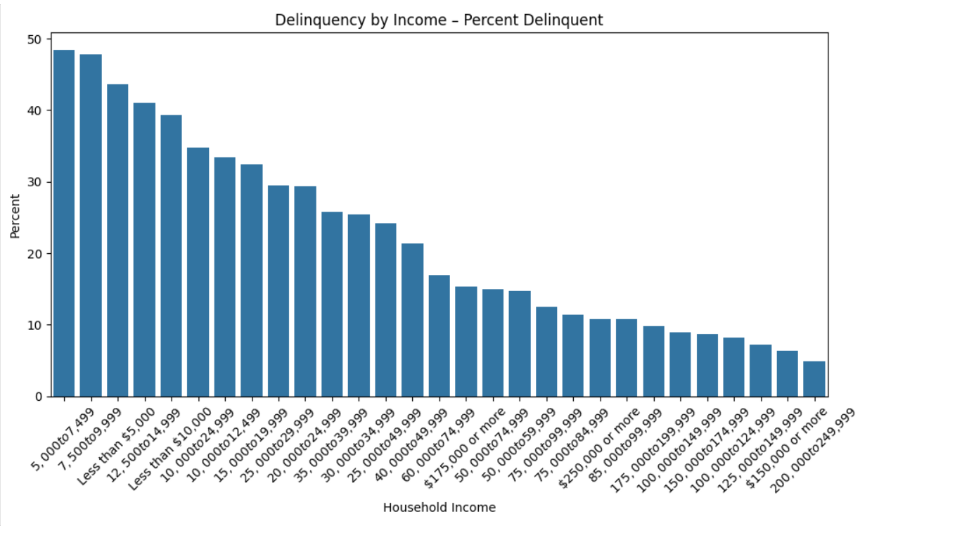

2. Grouped Bar Chart – Delinquency Rate by Race/Ethnicity (Pre vs. Post CARES)
Chart Title: Delinquency Rates by Race/Ethnicity: Pre-CARES vs. Post-Resumption
Caption:
This grouped bar chart compares delinquency rates across racial/ethnic groups before and after the CARES Act payment pause. Post-resumption rates remain elevated for Black and Hispanic borrowers, reinforcing racial disparities in student loan repayment.
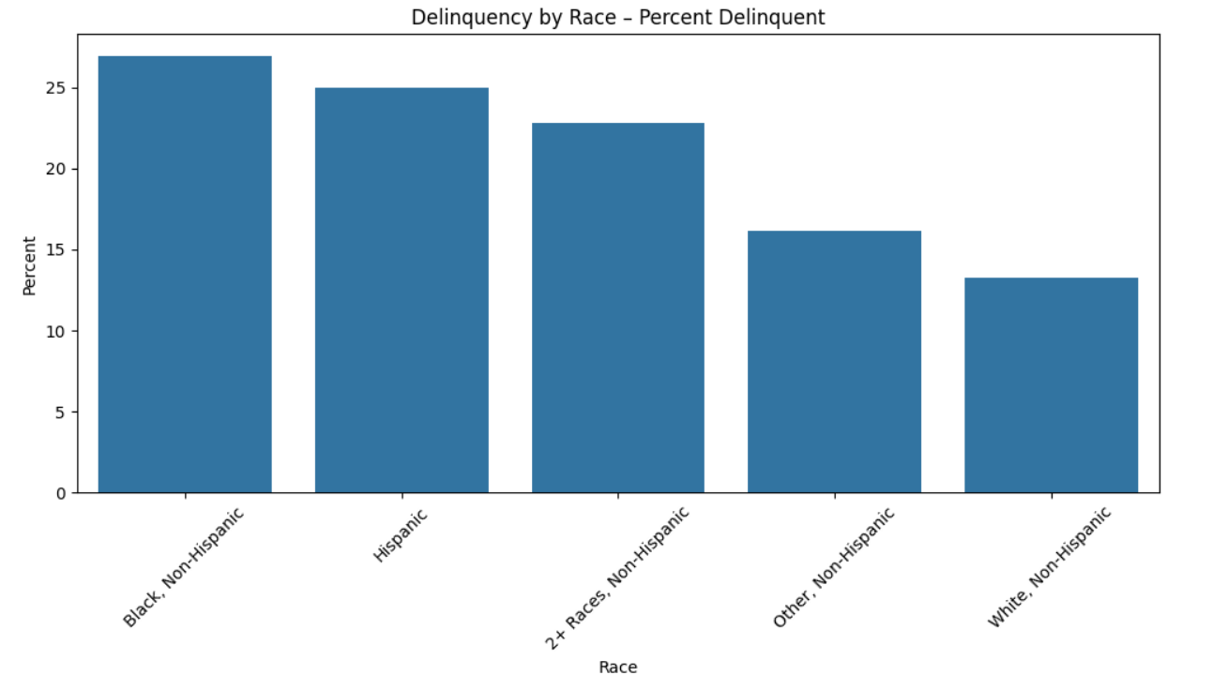

3. Heatmap – Feature Correlation Matrix
Chart Title: Correlation Among Predictive Variables
Caption:
The heatmaps display the pairwise correlation between key predictors. It helps assess multicollinearity and confirms that variables such as income and employment are sufficiently independent to be used together in the regression model.
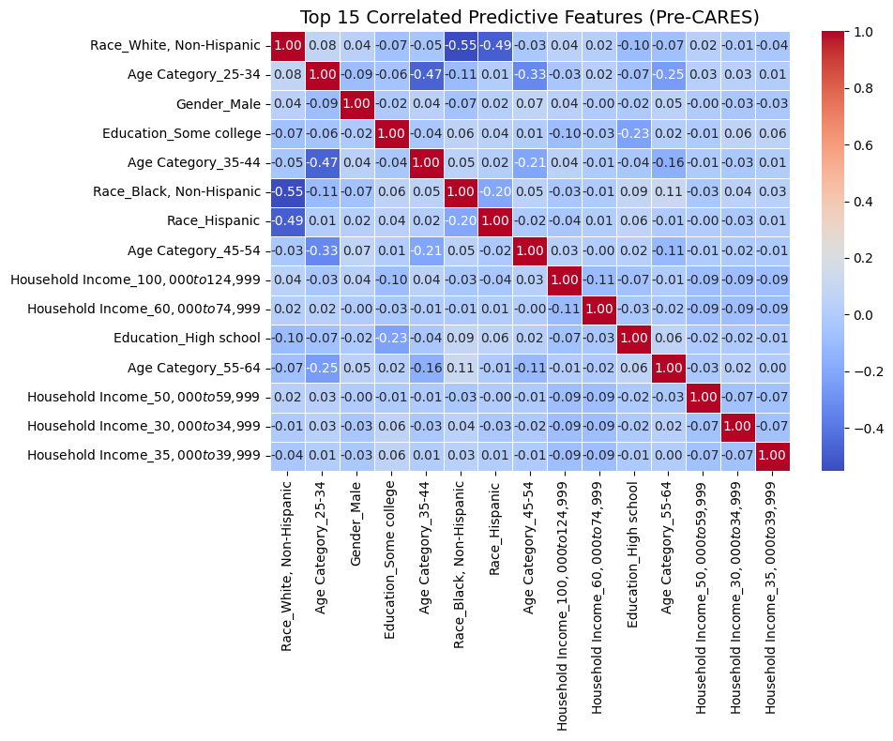
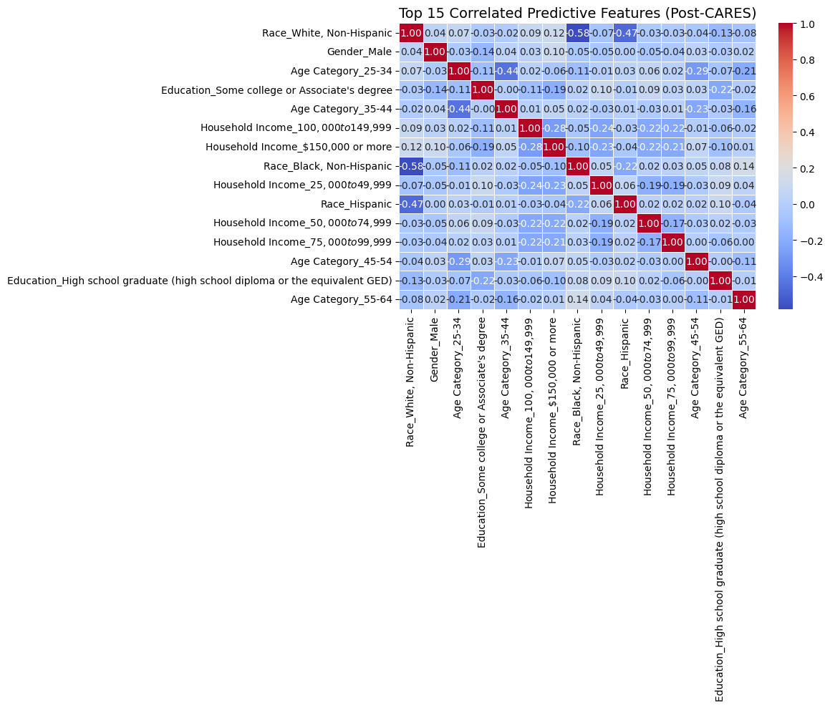
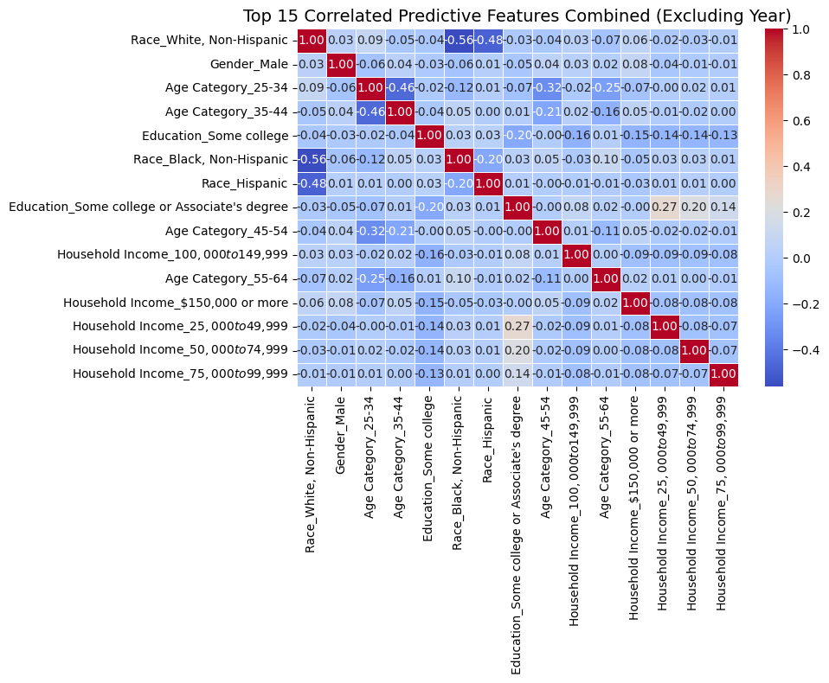

4. Bar Plot – Logistic Regression Coefficients (Odds Ratios)
Chart Title: Key Predictors of Student Loan Delinquency (Combined Model)
Caption:
This bar plot shows the exponentiated coefficients (odds ratios) from the combined logistic regression model. Borrowers reporting financial hardship were over 3x more likely to be delinquent. Low income and lack of emergency savings also significantly increased risk.
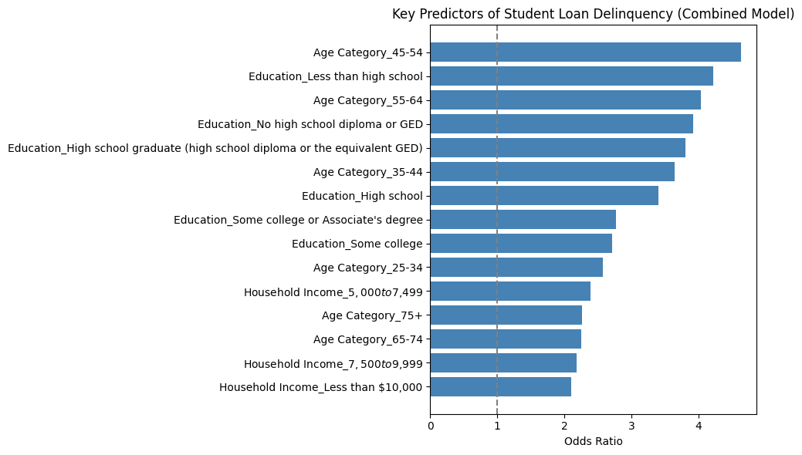
Explanation:
- Odds Ratio > 1: Increases the likelihood of delinquency
- Odds Ratio < 1: Decreases the likelihood (protective)
- OR = 1: No effect

5. ROC Curve – Model Performance Comparison
Chart Title: ROC Curves for Pre-CARES, Post-Resumption, and Combined Models
Caption:
This ROC plot compares model performance across time periods. The combined model achieved the highest AUC (0.77), indicating strong discriminatory ability. All models exceed the benchmark AUC of 0.70, supporting their reliability for classification.
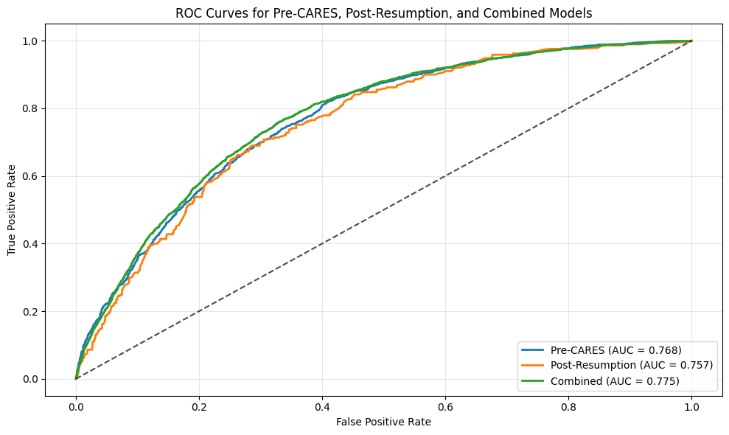
All three models show good discriminatory ability, they distinguish well between delinquent and non-delinquent borrowers. The combined model has the highest AUCs (0.775), suggesting tit performs best overall. The post-resumption model, while slightly lower (0.757), is still very strong, especially given the shifts in borrower behavior and conditions after the CARES Act pause ended.

6. Confusion Matrix – Post-Resumption Model
Chart Title: Confusion Matrix: Post-Resumption Logistic Regression Model
Caption:
This confusion matrix summarizes the classification results for the 2023-2024 model. The model correctly identified the majority of non-delinquent borrowers, but struggled to detect many actual delinquents, as reflected by the low recall (12%). This suggests the model is conservative in flagging risk, which may reduce false alarms but increases the likelihood of missing at-risk borrowers.
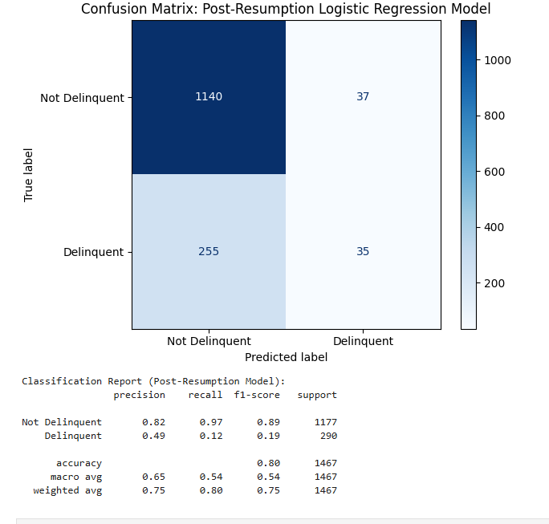

Appendix B:
Summary of Coefficient Comparisons Across Models
🔹 Age and Education Effects
- Age groups 35-64 consistently associated with higher delinquency risk across all models.
  - Example: Age 45-54 had odds ratios above 1.5 in pre-CARES and combined models.
- Borrowers with lower educational attainment (e.g., no high school diploma or only GED) had elevated odds of delinquency, supporting prior research on educational attainment and repayment stress.
🔹 Income Effects
- Higher income brackets (e.g., $150K+, $250K+) were strongly associated with lower delinquency risk across all models.
  - Post-resumption model showed the strongest protective effect (e.g., −1.57 coefficient for $150K+ income).
- Lower income levels (e.g., <$10K) showed positive associations with delinquency, though some income bands were excluded post-CARES due to sample constraints.
🔹 Shifts After Payment Resumption
- Many predictors (e.g., age, income, gender) had weaker or reversed effects post-resumption compared to pre-CARES.
  - Example: Age 35–44 dropped from 1.21 (pre) to 0.60 (post), suggesting reduced predictive strength post-pause.
- Some groups (e.g., Black borrowers, male borrowers) showed a decline or reversal in delinquency association in post-CARES data.
🔹 Combined Model Stability
- The combined model generally retained stronger and more stable coefficients, smoothing volatility between time periods.
- It performed best in terms of generalization while still capturing key borrower risk signals.
🔹 Year Effects (Combined Only)
- Dummy variables for survey years (2016-2024) were used in the combined model to control for external policy shocks.
  - These effects reflect CARES Act policy periods but were not included in the individual time-split models.
🔹 Coefficient Change Highlights (Delta Columns)
- Delta (Post-Pre): Largest drop in predictive power occurred for Race: Black, Non-Hispanic and Age: 35-44.
- Delta (Combined – Post): Showed rebound in income-based predictors, emphasizing that income effects remained strong, even if muted post-resumption.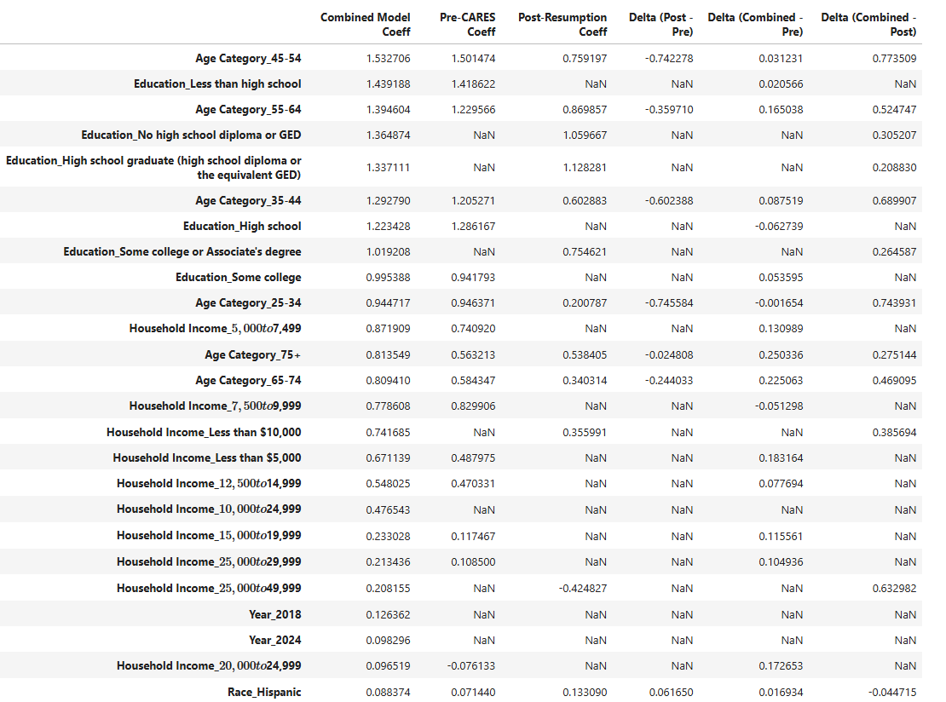

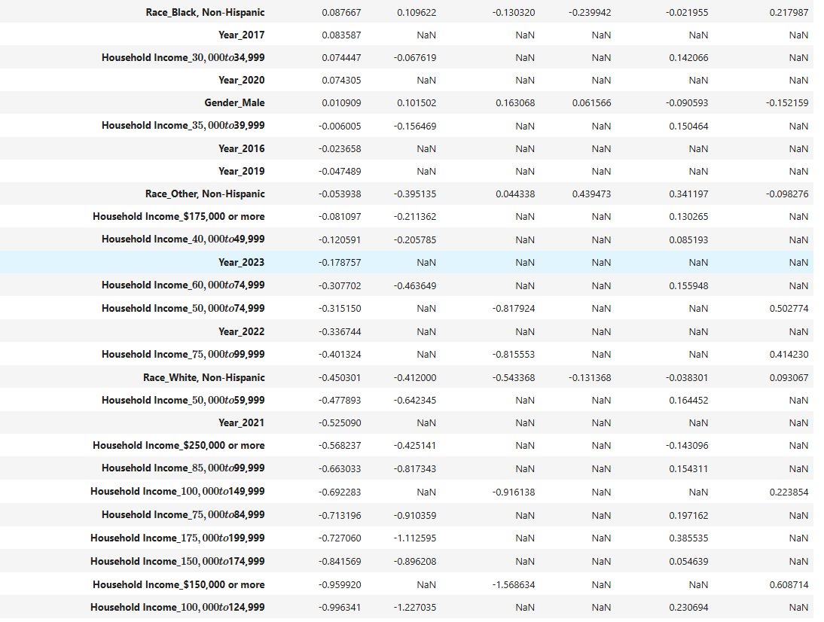

Appendix C:
Supporting Python Code

